Exercise 1:
Start
Enter Hours

- Lưu đồ giải thuật:
Enter Rate

Pay = 40*Rate +
(Hours-40)*1.5*Rate

Pay = Hours * Rate

if Hours > 40

Sai

Đúng

In Hours, Rate &
Pay

End

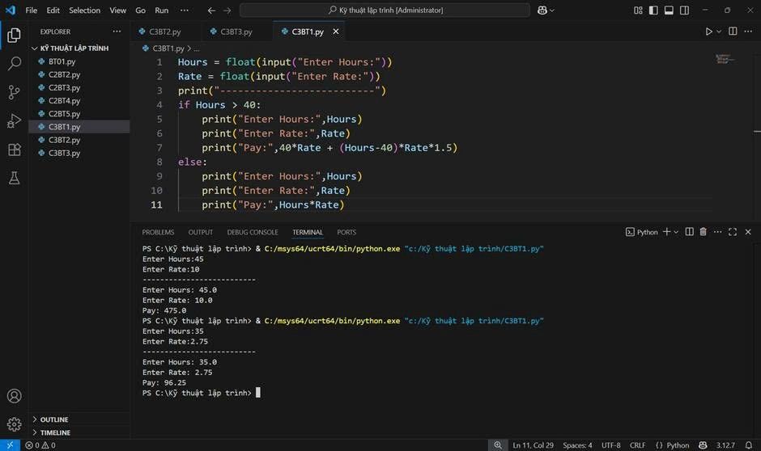
- Code:
Start
Exercise 2:
try:
Enter Hours
Enter Rate

- Lưu đồ giải thuật:
In “Error, please enter numeric input

Đúng
if Error

Saiv
Saiv
if Hours > 40
Pay = Hours * Rate

Đúng
Pay = 40*Rate +
(Hours-40)*1.5*Rate

In Hours, Rate &
Pay

End

- Code: 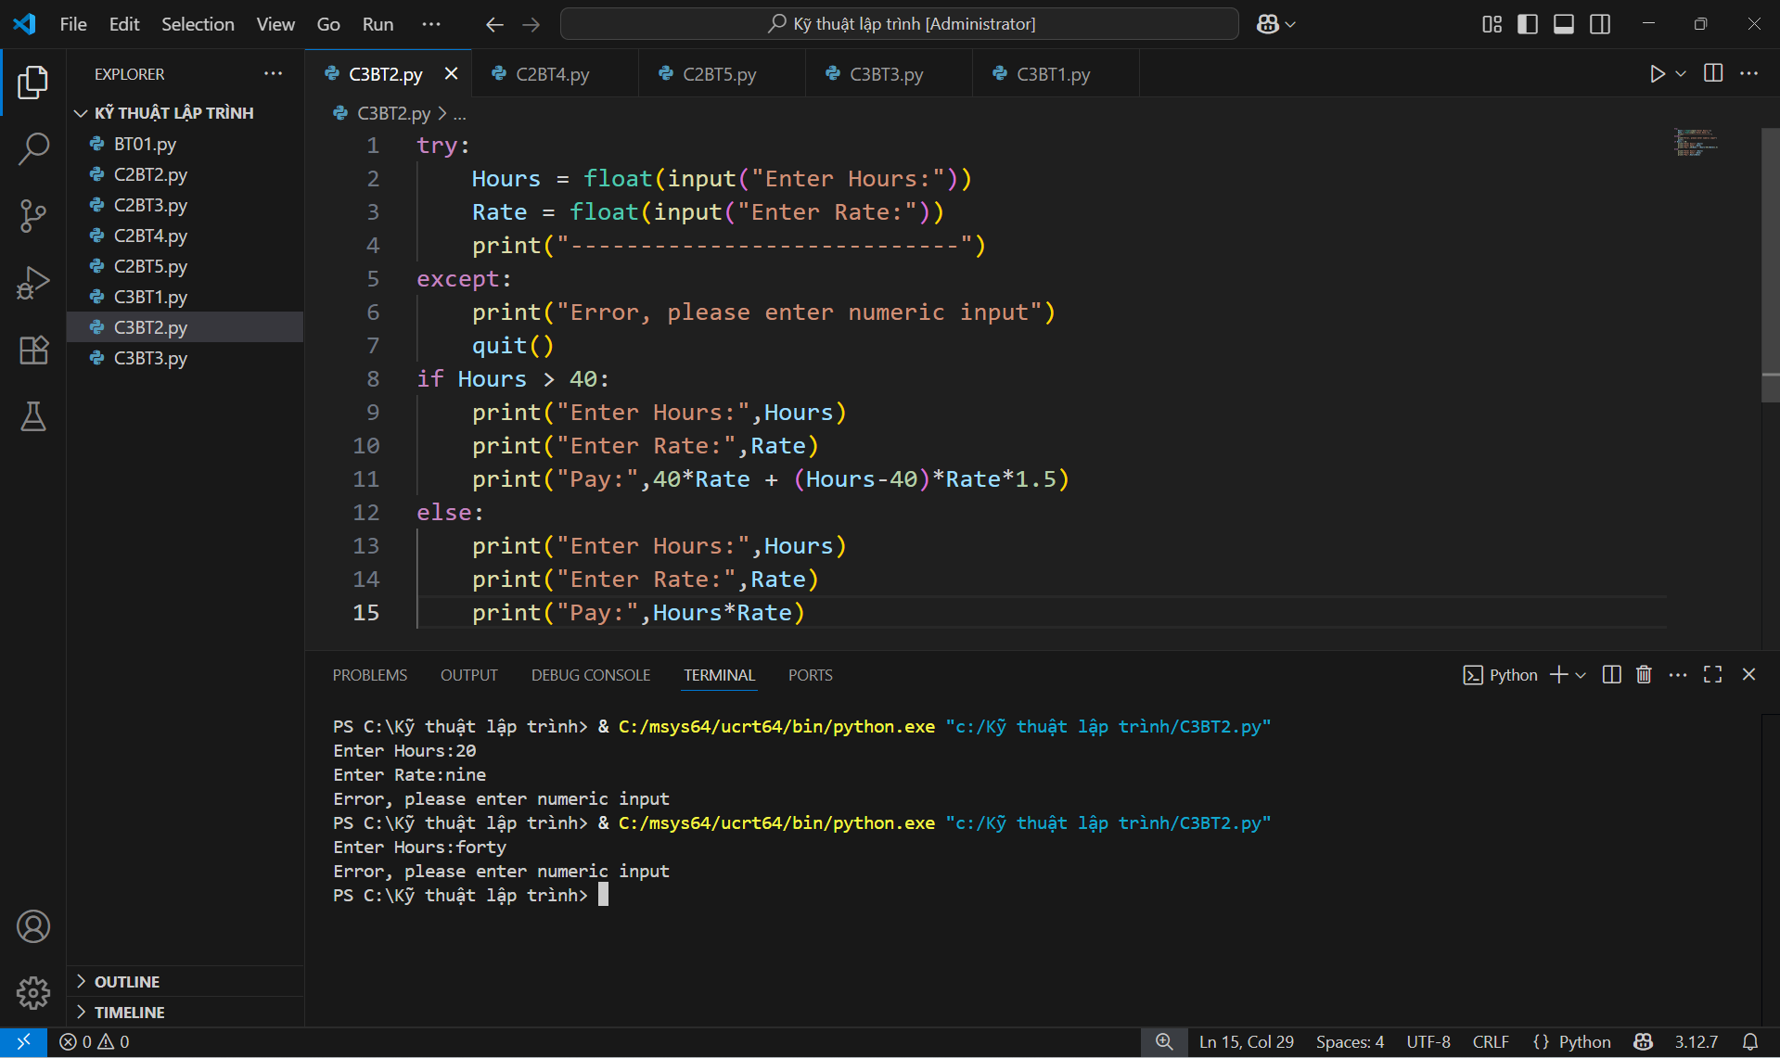
Exercise 3:
Start
try:
Enter Score
- Lưu đồ giải thuật:
Saiv
Đúng
Đúng
In Score
A

Saiv
Đúngv
Sai
Sai
elif Score>=0.6
Đúngv
elif Score>=0.7
Sai
Sai
Đúngv
Đúng
elif Score>=0.8
if Score>=0.9
if Score>=0.0 and Score<=1.0
if Error
type casting
Score
End
In Score
F

In Score
D

In Score
C

In Score
B

In Score
Bad Score

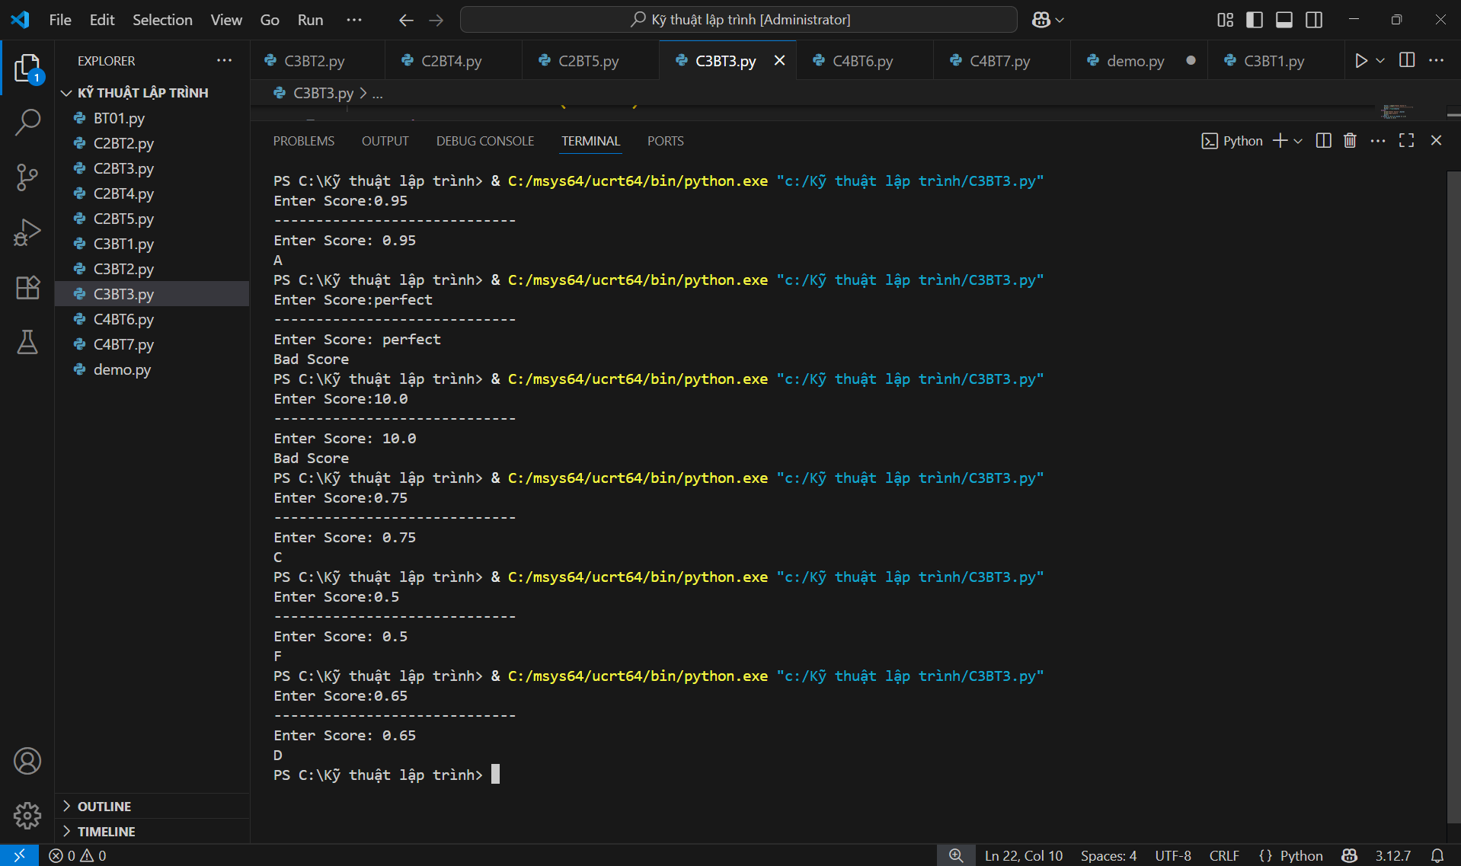
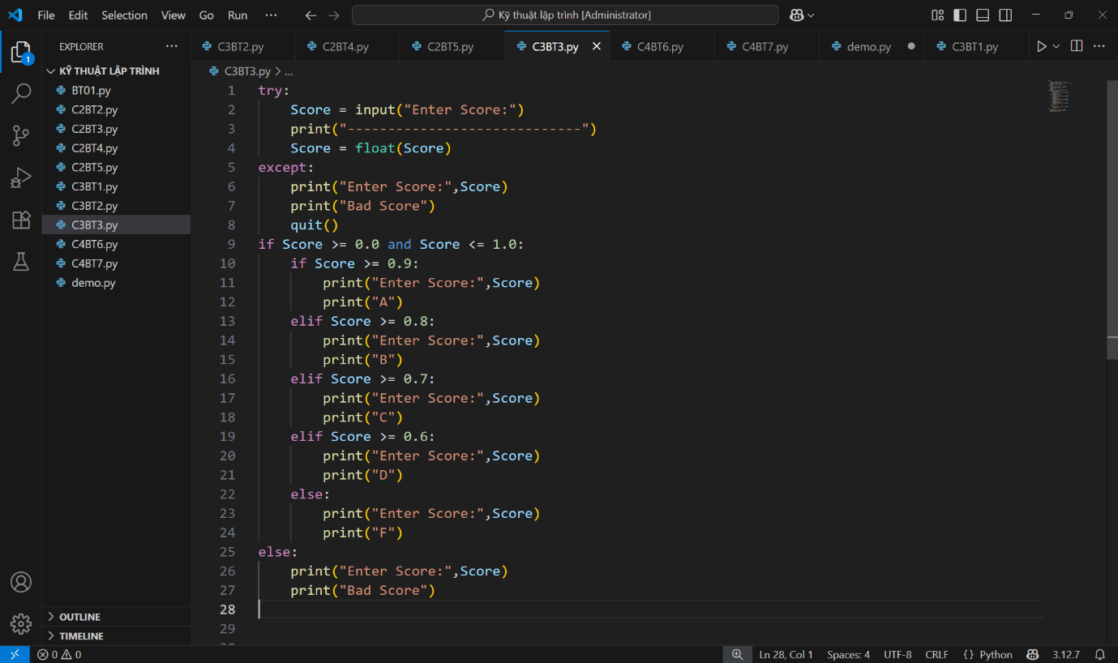
- Code:

